Exercise 16
- SELECT e_id, birth_date, p_email FROM employee_personalinfo WHERE MONTH(birth_date)=4;
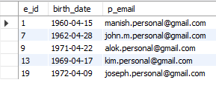
- SELECT e_id, birth_date, s_name FROM employee_personalinfo WHERE YEAR(birth_date)=1969 ORDER BY s_name ASC;
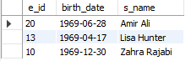
- SELECT e_id FROM employee_personalinfo WHERE MONTH(birth_date)=MONTH(CURRENT_DATE());
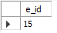
- SELECT COUNT(DISTINCT YEAR(birth_date)) AS unique_birth_years FROM employee_personalinfo;
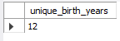
- SELECT YEAR(birth_date) AS birth_year, COUNT(*) AS employee_count FROM employee_personalinfo GROUP BY YEAR(birth_date);
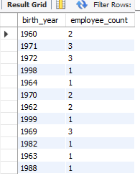
- SELECT MONTHNAME(birth_date) AS month_name, COUNT(*) AS employee_count FROM employee_personalinfo GROUP BY MONTH(birth_date), MONTHNAME(birth_date) ORDER BY employee_count DESC;